**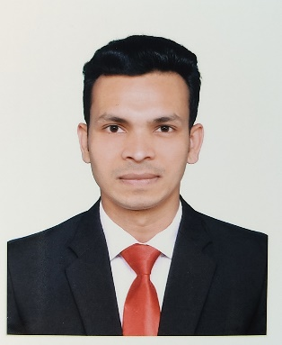MOHIUDDIN**

Vill : Mohoruddir Char

Post : Enayet Nagar(7920)

Thana : Kalkini

Dist : Madaripur

Cell : +88 01752437955

G-mail: [mohiuddincr7@gmail.com](mailto:mohiuddincr7@gmail.com)

**Career Objective:**

To Work in a challenging environment with a scope of future progress, applying my academic knowledge. I would like to welcome the chance to work as a part of a dynamic working team where I could make a significant contribution to establish career in a renowned multi-national company that demands honesty, integrity, dedication and strong sense of responsibility, efficiency and willingness.

**Special Qualification:**

I am very energetic and dedicated. I am regular and know the very basic required field. I think I am the best and most eligible candidate for your given post.

**Experience:**

Company : **Expert Interior Architects.**

Position : Executive, Sales & Marketing.

Location : 77, Dilara Tower, Bir Uttam CR Datta Road, Hatirpool, Dhaka

Duration : 09 April 2022 to 31 October 2023.

**Experience:**

Company : **Dew Interior Design.**

Position : Executive, Sales & Marketing.

Location : 47, A.T.C Tower, New Airport Road, Mohakhali, Banani Dhaka.

Duration : 01 November 2023 to Till Now.

**Language Skills:**

* Excellent verbal & written communication in mother tongue (Bangla).
* Good verbal & written communication in English language.

**Computer Skills:**

* Microsoft Office: MS Word, MS Excel, MS Power Point.
* Internet Browsing.
* Basic Knowledge of computer software maintenance & E-mail service.

**Interest:**

* Travelling
* Reading Book
* Sports
* Music & Movie

**Academic Qualification:**

**Master of Social Science (M.S.S)**

Subject : Political Science

Institution : National University

CGPA : 3.13 (on a scale of 4)

Year : 2019

**Bachelor of Social Science (B.S.S)**

Subject : Political Science

Institution : National University

CGPA : 3.06 (on a scale of 4)

Year : 2018

**Higher Secondary School Certificate (H.S.C)**

Group : Humanities

Institution : Kalkini Syed Abul Hossain University College.

GPA : 4.00 (on a scale of 5)

Year : 2014

Board : Dhaka

**Secondary School Certificate (S.S.C)**

Group : Science

Institution : Samitir Hat A.K Secondary School.

GPA : 4.25 (on a scale of 5)

Year : 2012

Board : Dhaka

**Personal Information:**

Father’s Name : Motiur Rahaman

Mother’s Name : Safali Begum

Present Address : Vill: Mohoruddir Char, Post: Enayet

Nagar, Pst: Kalkini, Dist: Madaripur.

Permanent Address : Vill: Mohoruddir Char, Post: Enayet

Nagar, Pst: Kalkini, Dist: Madaripur.

Date of Birth : 02, October, 1997

Gender : Male

Marital Status : Unmarried

Nationality : Bangladeshi

Religion : Islam

Blood Group : B-

**REFERENCES:**

Md. Biplob Mia

Head of Sales

Siam Bangla Industries Ltd

(Manufacture of White Cement)

THE SIAM CEMENT TA LUNG CO., THAILAND

Cell: +8801727-547389

applicant_signature.jpg

Signature

Mohiuddin